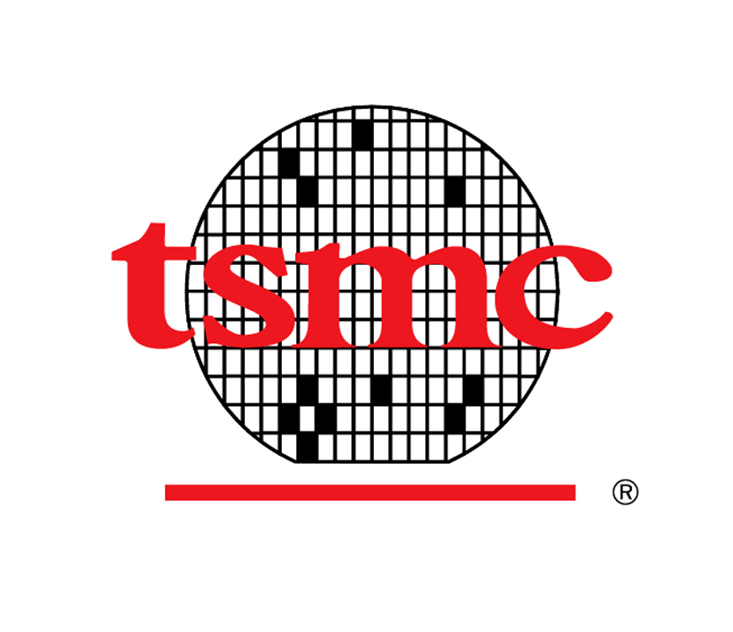
Taiwan Semiconductor Manufacturing Company, Ltd.

Personnel Information Form
人事資料表

TSMC Use Only  台積內部填寫 |  |  | Payroll No. |  |  |  |  |  |  |  |  |  |  |  |  | Dept. |  |  |  |  |  |  |  |  |  |  |  |  |  |  |  |  |  |  |  | Date Employed |  |  | mm/dd/yyyy  西元月/日/年
* Please fill out the form in English or Chinese 請使用英文或中文填寫此資料表
Job Applied For  申請職務 |  |  | 1. |  |  |  |  |  |  |  |  |  |  |  |  |  |  |  |  |  |  |  |  |  |  |  | 2.

A. General Information 個人基本資料
Name  姓名 | Chinese  中文 |  |  |  |  |  |  |  |  |  |  |  |  |  |  |  |  |  |  |  |  |  | Nationality  國籍 |  |  |  |  |  |  |  |  |  |  | □ R.O.C. 中華民國
Name  姓名 | English  英文 |  |  |  |  |  |  |  |  |  |  |  |  |  |  |  |  |  |  |  |  |  |  |  |  |  |  |  |  |  |  |  |  | □
Name  姓名 | Have you ever changed your name?您是否曾更改過姓名？  □ No否 □ Yes是 Name before changed原名：
Birth Date  出生日期 |  |  |  | mm/dd/yyyy  西元月/日/年 |  |  |  |  |  |  |  |  |  |  |  |  |  |  |  |  |  |  | Gender  性別 |  |  |  |  |  |  |  |  |  |  | □ Male男 □ Female女
I.D. No.  身分證字號 |  |  |  |  |  |  |  |  |  |  |  |  |  |  |  |  |  |  |  |  |  |  | Phones  電話 |  |  |  |  |  |  |  |  |  |  | (Tel)  (Cell)

E-mail Address
電子郵件
Mailing Address  通訊地址 |  |  |  | □□□
Military Service  兵役狀況 |  |  |  | Service  軍種 |  |  |  |  |  |  | Rank  軍階 |  |  |  |  |  |  |  |  | Status  狀況 |  |  |  |  |  |  |  |  |  |  | Period  期間 |  |  |  | From起 Yr年 M月  To迄 Yr年 M月
 |  |  |  | Certificate No.  退伍令字號 |  |  |  |  |  |  |  |  |  |  |  |  |  |  |  | Reason of Exemption & Certificate No.  免役原因及證明字號

B. Education, Specialty & Language Ability 教育、專長與語文能力
Grade  階段 |  |  |  | Name of School  學校名稱 |  |  |  |  |  |  | Location  地點 |  |  |  | Major  科系 |  |  |  |  |  |  | From起 |  |  |  |  |  |  |  | To迄 |  |  |  |  |  | Graduated  是否畢業 |  |  |  | Type  日/夜間部 |  |  | Highest Degree  最高學歷
 |  |  |  |  |  |  |  |  |  |  |  |  |  |  |  |  |  |  |  |  |  | M月 |  |  |  | Yr年 |  |  |  | M月 |  | Yr年 |  |  |  | Yes |  | No |  |  |  |  | Highest Degree  最高學歷
High School  高中(職) |  |  |  |  |  |  |  |  |  |  |  |  |  |  |  |  |  |  |  |  |  |  |  |  |  |  |  |  |  |  |  |  |  |  |  |  |  |  |  | □Day 日間部  □Night夜間部
Jr. College  專科 |  |  |  |  |  |  |  |  |  |  |  |  |  |  |  |  |  |  |  |  |  |  |  |  |  |  |  |  |  |  |  |  |  |  |  |  |  |  |  | □Day 日間部  □Night夜間部
University  大學 |  |  |  |  |  |  |  |  |  |  |  |  |  |  |  |  |  |  |  |  |  |  |  |  |  |  |  |  |  |  |  |  |  |  |  |  |  |  |  | □Day 日間部  □Night夜間部
Post Graduate
(Master)
研究所(碩士)
Post Graduate
(PhD)
研究所(博士)
Other
其他

Describe any special vocational or technical training and specialized knowledge/skill 請說明您的專業知識與技能

In summary, key words of your expertise are: 您專業技能的關鍵字詞為何(註：關鍵字有助於迅速搜尋相關人才)

Academic Ranking: select the class academic ranking
個人在學成績排名
- 大學 Bachelor : □ Top 5% □6%~10% □11%~20% □21%~30% □31%~50% □51%~100%
- 研究所Master : □ Top 5% □6%~10% □11%~20% □21%~30% □31%~50% □51%~100%
Academic Award: indicate the Presidential Award, Phi Tau Phi Scholastic Honor, or other international/national contest awards.
學術獎項: 請提供個人書卷獎、斐陶斐榮譽學會會員、或其他國際性/全國性競賽獲獎紀錄
Award  獎別 |  |  |  |  |  |  |  |  |  |  |  |  |  |  |  |  |  | Year Received  獲獎時間(年)

1.

2.

3.
License or Certificate  專業證照或檢定證書 |  |  |  |  |  |  |  |  |  |  |  |  |  |  |  |  |  | Date of Issue  發照日 |  |  |  |  |  |  |  |  |  |  | Certificate No.  證照字號 |  |  |  |  |  |  |  |  |  |  |  | Remarks  備註

1.

2.
Language Ability: indicate the language and your proficiency, i.e. Excellent, Good, Useful, A little, Not at all.
語文能力：請以極佳、佳、普通、略通或不通說明您對該語文的熟練程度
Second Language and so on  第2、3...外國語 |  |  |  |  |  |  |  |  |  |  |  |  |  |  |  |  |  | Read  讀 |  |  |  |  |  |  |  |  |  | Write  寫 |  |  |  |  |  |  |  |  | Speak  說 |  |  |  |  | Remarks  備註
1. English
2.
3.
English typing speed 英打速度 W/M(字/分) |  |  |  |  |  |  |  |  |  |  |  |  |  |  |  |  |  |  |  |  |  |  | Chinese typing speed 中打速度 W/M(字/分)

C. Working Experience : It is at your discretion to provide the information of supervisor and compensation.

工作經驗:直屬主管及薪資資料請自行斟酌是否填寫
From 起 |  | To 迄 |  | Title /  On Grade Year  職稱/在職年資 |  |  | Co. Name  公司名稱  (請填入公司全名) |  |  | Co. Location  (Country)  公司所在地點 |  | Supervisor  直屬主管 |  |  |  |  | Compensation  薪資 |  |  |  |  |  | Reason  for Leaving  離職原因
M月 | Yr年 | M月 | Yr年 |  |  |  |  |  |  |  |  | Name  姓名 |  |  | Title  職稱 |  | Monthly Base Salary 月薪 |  |  | Allowance  /Bonus  津貼/獎金 |  | Others  其他 | Reason  for Leaving  離職原因
May we contact your present employer? 台積公司是否可與您的現任雇主聯絡查證 □ No否 □ Yes是
We shall not do so without your consent. 未經您同意台積公司絕不會聯絡您的現任雇主
Describe your experience, major achievement during each of the period mentioned above.
請摘要您於上述各職務的主要成就

D. Others 其他
Do you have any relatives or friends working in tsmc? 目前是否有任何親屬、朋友任職於台積公司？
□ No 否 □ Yes 是 If yes, please specify the name, relation and dept. 如有，請列出姓名、關係及任職部門
Name  姓名 |  |  |  |  | Relation  關係 |  |  | Department  部門 |  |  | Name  姓名 |  |  |  |  | Relation  關係 |  |  | Department  部門
Reference Check : Please provide minimum of three names. Your supervisor(s), research advisor(s) or teacher(s) must be included in.
資歷查核: 請至少提供三位查核對象，其中至少含直屬主管、論文指導教授或授課教師
Name  姓名 |  |  |  |  | Relation  關係 |  |  |  | Company / Dept.  公司/部門 | Title  職稱 |  |  | Contact  聯絡方式
 |  |  |  |  |  |  |  |  |  |  |  |  | (Tel)  (Cell) |  |  |  |  | E-mail:
 |  |  |  |  |  |  |  |  |  |  |  |  | (Tel)  (Cell) |  |  |  |  | E-mail:
 |  |  |  |  |  |  |  |  |  |  |  |  | (Tel)  (Cell) |  |  |  |  | E-mail:

What do you expect most of the job that you are applying for? Please tick and explain briefly.
您對下一份工作最重視的項目為何，請勾選並簡要說明
Aspect 項目 |  |  |  |  |  | Why 原因 |  |  |  |  | Aspect項目 |  |  |  |  |  |  | Why原因
□ Greater responsibility  擔負更大的責任 |  |  |  |  |  |  |  |  |  |  | □ New field of work新領域
□ Salary薪資 |  |  |  |  |  |  |  |  |  |  | □Opportunities of learning & development訓練與發展的機會
□ Job security工作保障 |  |  |  |  |  |  |  |  |  |  | □ Different location  工作地點
□ Others其他
When will you be available for the new job if you are recruited?  如獲任用何時可以報到？ Yr年 M月 Date日 |  |  |  |  |  |  |  |  |  |  |  |  |  | Expected Salary  期望薪資 |  |  |  |  |  |  | NT$

Which channel did you learn the job opening? 您自何處得知此職缺
□ Campus 學校 □ Job bank人力銀行 □ Newspaper ad.報紙廣告
□ Magazines 雜誌 □ Friends / Relatives親友 □ Teachers/Advisors 授課教師/指導教授
□ Employment Service Office 就業服務站 □ Others 其他，請說明___________________
Additional information you wish to add 其他補充資訊

E. Optional Information: The following information is optional. TSMC provides equal employment opportunity to all job applicants in compliance with the Employment Service Act of Taiwan (R.O.C.).

選填資訊: 以下資訊可依個人意願填答。依據就業服務法，台積公司提供求職者公平的求職機會。
Personal Information 個人資料 |  |  |  | Photo  照片
Marital Status  婚姻 | □ Single單身 □ Married已婚 |  |  | Photo  照片
Permanent Address  戶籍地址 | □□□ |  |  | Photo  照片
Interests & Hobbies  興趣、嗜好 |  |  |  | Photo  照片
Family Information: including parents, guardian, spouse, children & siblings.  家庭資料:父母、監護人、配偶、子女及兄弟姊妹 |  |  |  | Photo  照片
Relationship  關係 | Name  姓名 | Age  年齡 | Occupation  職業 | City of Residence  居住城市
Father父
Mother母
Spouse配偶
Children 子女
Are you qualified for the below status as specified by law? 您是否具有以下之法定身分?
□ Indigenous people原住民 □ Individuals with disabilities身心障礙者
We welcome applicants with any of the above specifications. 台積公司歡迎具有以上法定身份之求職者求職。
Have you ever been prosecuted or indicted for any intentional crime? 您是否曾因刑事故意犯罪而遭受偵查或起訴？
□ No否 □ Yes是 What請說明 ___________________
Are you on the wanted list? 是否遭任何國家通緝？
□ No否 □ Yes是 What請說明 ___________________

I hereby authorize TSMC to verify the accuracy of all the statements made and the personal information provided in this Form (“Information”), and I fully understand that any falsification in this Form constitutes a sufficient and just cause for dismissal of my employment if hired.
I hereby consent and authorize TSMC and its affiliated entities, employee welfare committees of TSMC and its affiliated entities, TSMC Education and Culture Foundation and any other third parties authorized by the above entity or entities to collect, process and use, domestically and internationally, the personal information that I provided or will provide for the purposes of TSMC's recruitment process, personnel management and business operation in accordance with relevant laws governing the protection of personal information, and to retain the information for at least 15 years after all the aforementioned purposes no longer exist.
In addition, I acknowledge that TSMC had informed me precisely the purposes of collecting the Information, the classification of the Information, the time period, areas, targets and ways of using the Information, my rights under Article 3 of Personal Information Protection Act and the ways to exercise them, and the consequences if I choose not to provide the Information.

本人謹此授權台積公司得就本人於此人事資料表中所提供之陳述與個人資料內容之正確性進行確認。本人充分瞭解在此人事資料表中所為之一切陳述如有虛偽不實，將足以構成終止聘僱合約之事由。
本人並特此同意及授權台積公司及其關係企業、台積公司及其關係企業之職工福利委員會、台積電文教基金會及以上公司及組織所委託之第三人為招募聘用、人事管理及業務執行之目的，在符合個人資料保護相關法令之範圍內，蒐集、於國內與國際間處理、利用本人已經提供及未來將提供的個人資料，並得於特定目的消失後保存至少十五年。
本人亦確認台積公司已依個人資料保護法及相關法令之規定，明確告知本人本人事資料表內個人資料之蒐集目的、個人資料類別、利用之期間、地區、對象及方式、依個人資料保護法第三條規定得行使之權利及權利行使方式、及不提供本人本履歷表、人事資料表內個人資料時將對本人權益之影響。

Signature 簽名 Date 日期
I hereby declare that I will comply with all TSMC regulations during my employment. In case of any violation, I agree to accept and be bound by applicable penalties as specified in the TSMC Work Rules and relevant rules.
本人同意並保證：本人於在職期間將遵守台積公司所有相關規定。如有違反，本人同意接受工作規則及其他相關規定之懲處。

Signature簽名 Date日期

