Deep Learning Networks – Architectural Evolution and

Theoretical Foundation

C.-C. Jay Kuo
University of Southern California

This talk will focus on one particular type of deep learning networks known as the “multi-layer perception (MLP)”, “multi-layer feedforward networks” and “Convolutional neural networks (CNNs). It examines two topics in depth – network architectural evolution and theoretical foundation. For network architectural evolution, I will begin with the McClulloch and Pitts (M-P) neuron model and network in 1943, then the artificial neural network (ANN) in 80s and 90s, and finally the modern convolutional neural network (CNN) since late 90s. The differences between these three generations of networks will be clearly explained. Furthermore, there are three main types in modern CNNs: pyramidal CNNs, fully convolutional networks (FCN) and residual networks. Their specific functions are explained. For theoretical foundation, researchers have studied properties of CNNs from three viewpoints: the approximation theory viewpoint, the optimization theory viewpoint and, recently, the signal analysis viewpoint. I will present main results from each viewpoint. A good understanding of both topics provides valuable insights into the past, the present and the future of CNN research and applications.

Speaker’s Biography
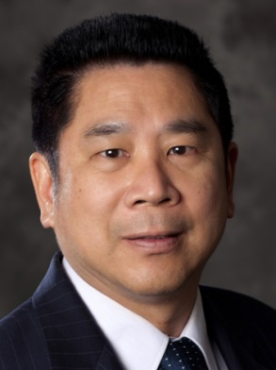
Dr. C.-C. Jay Kuo received his Ph.D. degree from the Massachusetts Institute of Technology in 1987. He is now with the University of Southern California (USC) as Director of the Media Communications Laboratory and Dean’s Professor in Electrical Engineering-Systems. His research interests are in the areas of digital media processing, compression, communication and networking technologies. Dr. Kuo was the Editor-in-Chief for the IEEE Trans. on Information Forensics and Security in 2012-2014. He was the Editor-in-Chief for the Journal of Visual Communication and Image Representation in 1997-2011, and served as Editor for 10 other international journals. Dr. Kuo received the 1992 National Science Foundation Young Investigator (NYI) Award, the 1993 National Science Foundation Presidential Faculty Fellow (PFF) Award, the 2010 Electronic Imaging Scientist of the Year Award, the 2010-11 Fulbright-Nokia Distinguished Chair in Information and Communications Technologies, the 2011 Pan Wen-Yuan Outstanding Research Award, the 2014 USC Northrop Grumman Excellence in Teaching Award, the 2016 USC Associates Award for Excellence in Teaching, the 2016 IEEE Computer Society Taylor L. Booth Education Award, the 2016 IEEE Circuits and Systems Society John Choma Education Award, the 2016 IS&T Raymond C. Bowman Award, and the 2017 IEEE Leon K. Kirchmayer Graduate Teaching Award. Dr. Kuo is a Fellow of AAAS, IEEE and SPIE. He has guided 140 students to their Ph.D. degrees and supervised 25 postdoctoral research fellows. Dr. Kuo is a co-author of about 250 journal papers, 900 conference papers and 14 books.

